Bylaw No. 549.1, 2026
A bylaw to amend the North Coast Regional District Development Approval Procedures and Fees Bylaw No. 549, 2013.

WHEREAS the Board of the North Coast Regional District has adopted Official Community Plans and Zoning Bylaws;

AND WHEREAS Section 460 of the Local Government Act provides that where a local government has adopted an official community plan or a zoning bylaw, the local government must, by bylaw, define procedures under which an owner of land may apply for an amendment to the plan or bylaw or for the issuance of a permit or flood plain exemption under Part 14 of the Local Government Act;

AND WHEREAS the Board may, pursuant to s. 229 of the Local Government Act, delegate its powers, duties and functions;

NOW THEREFORE the Board of the North Coast Regional District, in open meeting assembled, HEREBY ENACTS as follows:

- Citation
This bylaw may be cited for all purposes as the North Coast Regional District Development Procedures Amendment Bylaw No. 549.1, 2026.
- Amendments

- That the definitions in section 2.1 be amended to remove “Corporate Officer”; and include:

“Planning Officer means the North Coast Regional District Planning and Economic Development Officer, or their designate.”

- That references to “Corporate Officer” throughout the bylaw and its schedules be replaced with “Planning Officer”.

- That Part Four – Delegation of Decision Making and Reconsideration by the Board be replaced with the following:
“4.1 Delegation to Planning Officer
Pursuant to section 229 of the Local Government Act, the Board delegates to the Planning Officer:
    - the powers of the Board under section 490 of the Local Government Act to issue and amend development permits for the following purposes and in situations where the permit does not incorporate a variance to a bylaw:
- protection of the natural environment, its ecosystems and biological diversity (“Environmental Development Permits”); and
- protection of development from hazardous conditions (“Natural Hazards Development Permits”)
    - the powers of the Board under section 493 of the Local Government Act to issue Temporary Use Permits consistent with an Official Community Plan.
    - the authority of the Board to require development approval information under section 486 of the Local Government Act.”
2.4 That Section 5.3.3 be amended to read:3
“Upon receipt of the referral comments, the Planning Officer will incorporate all feedback into a Post-Referral report to be provided to the Applicant. The Applicant may provide a written response to the Post-Referral report, responding to any issues raised in the Report and proposals for resolution. These proposals may include, but are in no way limited to a requirement for security by an irrevocable letter of credit or other means in a form satisfactory to the NCRD in an amount stated in the permit to guarantee performance of the permit. ”
2.5 That Section 5.3.4 be amended to read:
“After receiving a response the applicant on the Post-Referral Report, the Planning Officer will review the application and responses within the stated guidelines for temporary use permits; as well as the objectives and policies of Official Community Plans and Economic Development. Where the Planning Officer is satisfied that the application is consistent with the applicable guidelines, objectives and policies , the Planning Officer may proceed with notification. Where the Planning Officer is not satisfied, staff may request further information or deny the application.”
2.6 That Section 5.3.5 be amended to read:

“Prior to consideration to issue the proposed temporary use permit and pursuant to the Local Government Act,

- notice of a proposed temporary use permit will be advertised by the Regional District in the newspaper at least three days and no more than 14 days before the intended date of consideration of the application, will be advertised on the Regional District website at least 30 days before the intended date of consideration, and will be mailed or otherwise delivered to property owners within 100 meters, at least 30 days before the intended date of consideration.

- The Applicant shall, at their own expense, be required to place an approved sign of no less than 1 square meter in a conspicuous location facing the roadway. The sign shall clearly indicate:
- The contact information for the NCRD planning office,
- the assigned application number,
- the purposes of the proposed permit,
- the property affected by the permit, and
- the deadline for public comments.”

2.7 That Section 5.3.8 be amended to read: “Following review of the application; Regional District bylaws, and feedback received the Planning Officer may then:

- authorize the issuance of the TUP or authorize the issuance of the TUP with conditions;
- refer it back to the Electoral Area Advisory Committee for recommendations, or
- reject the application.

2.8 That Section 7.3 be amended to read:

“7.3: Reconsideration

Where staff have denied an application for a permit which has been delegated under this bylaw, the property shall be notified in writing of their right to request reconsideration by the Board within 15 days of the decision. Staff shall provide the application to the Board, along with a technical review and consolidated feedback. Following review, the Board may, by resolution:
- issue the permit, or
- deny the application.

2.9 That Section 7.4 be added, to read:

“7.4 Irregularity

The failure of the Board or Corporate Officer to observe the provisions of this Bylaw does not affect the validity of resolutions passed or bylaws enacted by the Board.”

2.10 That Schedule B be replaced by the amended Schedule B, attached to and forming a part of this bylaw.

Read a first time this 27th day of February, 2026
Read a second time this ___ day of ________, ____
Read a third time this ___ day of ________, ____
Adopted this ___ day of ________, ____

___________________ ___________________
Chair Corporate Officer

I hereby certify that this is a true copy of the North Coast Regional District Bylaw No. 549.1, 2026.
SCHEDULE B – APPLICABLE FEES
- Payment Due:
All fees, unless otherwise specified, are to be paid in full when the application is submitted.
- Advertising Cost:
Advertising costs are costs incurred to give sufficient public notice for any public hearings or to provide notice when the requirement to hold a public hearing has been waived. These costs, as estimated by the Corporate Officer, are payable when the application is submitted. If the application is withdrawn prior to public notification, any funds received for advertising will be refunded.
- Mapping:
When maps are required as attachments or schedules to the bylaws or for other purposes related to the application, the cost of producing and printing the maps will be the responsibility of the applicant. These costs, if incurred through the Regional District, are payable prior to the public hearing.
- Amendment to an Application:
For all Official Community Plan and rezoning applications, an amendment after work has been undertaken on the application requires a new application and additional fee in the amount equal to 70% of the original application.
- Other fees:
Fees for agencies such as the Agricultural Land Commission, legal services, professional consultation, and other expenses such as covenant registration and special travel arrangements for staff or consultants will be billed at cost and are payable upon receipt of invoice.
- Signage:
The cost of signage to identify the subject property under application (section 5.11.2) is the responsibility of the applicant.
- Refunds:

Refunds
Application withdrawn within 21 days | 50% of applicable fee
Bylaw amendment applications prior to 1st Reading | 50% of applicable fee
Public Hearing prior to 1st Reading | 100% of Public Hearing fee
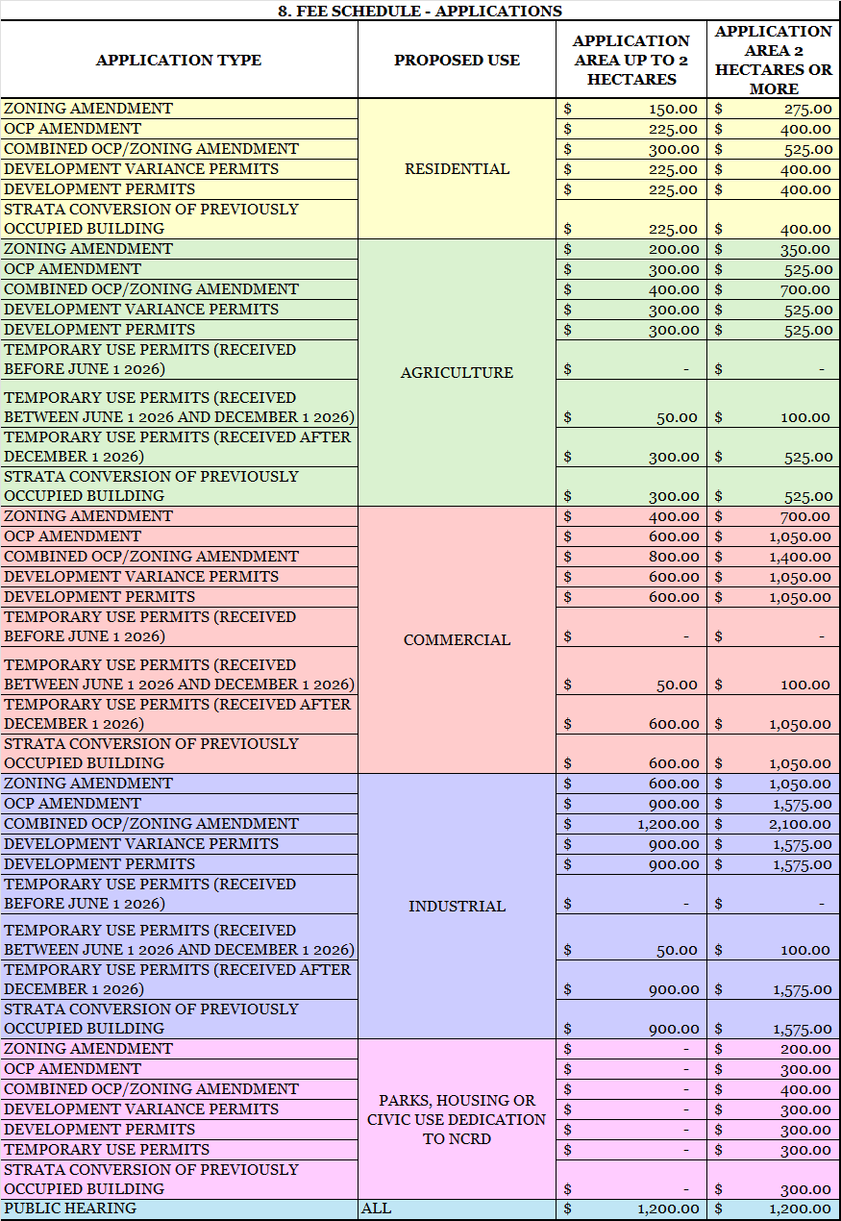
9. FEE SCHEDULE - MISCELLANEOUS
INITIAL INFORMAL REVIEW | FREE
PRE-PLANNING CONSULTATION (HOURLY) | $ 75.00
PRE-APPLICATION SITE INSPECTIONS | $ 1,200.00
AMENDMENTS TO LEGAL AGREEMENTS IN FAVOUR OF THE NCRD | $ 300.00
ZONING BYLAW PRINTING | $ 15.00
OCP BYLAW PRINTING | $ 25.00
MAP & POSTER PRINTING SERVICES (HOURLY) | $ 100.00
MAP & POSTER PRINTING (8X11 BLACK AND WHITE) | $ 0.15
MAP & POSTER PRINTING (8X11 COLOUR) | $ 0.30
MAP & POSTER PRINTING (24X36 BLACK AND WHITE) | $ 5.00
MAP & POSTER PRINTING (54X36 COLOUR) | $ 8.00
MISC PRINTING (PER PAGE) | $ 0.15

